**Net3006A Network Management and Measurements** (Winter 2025)

Assignment 1 (covering Lectures 2, 3 and 4) **–** Due by 11:59pm, Jan. 31 Please submit **a single PDF file** on Brightspace (“Tools/Assignments/Assignment 1”)

**Q1.** [0.8 Points] Answer the following questions in one or two sentences.

**Grading Rubric**: 0.2 points for each sub-question. For sub-question a, one correct explanation or example is sufficient.

1. Why is a network’s status time-varying? You can explain with an example if that helps.
2. What is a “content provider network”?
3. Briefly explain what a management information base (MIB) is.
4. What are the benefits of having a distributed network management system?

**Q2.** [0.8 Points] Answer True or False for each of the statements below and briefly explain why in one or two sentences.

**Grading Rubric**: 0.2 points for each sub-question.

* + Answer (True/False) correct, explanation (mostly) correct: 80-100%
  + Answer correct, explanation (at least partially) correct: 60-80%
  + Answer correct, no explanation or explanation irrelevant/incorrect: 50-60%
  + Answer incorrect, explanation relevant and (at least partially) correct: 0-50%
  + Answer incorrect, no explanation or explanation irrelevant/incorrect: 0%

1. A network equipment (i.e., managed device) can have multiple management interfaces.
2. High end-to-end throughput implies low end-to-end delay.
3. The “configuration management” as defined by the International Standards Organization is a concern of network provisioning and network operations, but not network administration or network maintenance.
4. A network device cannot play an agent role and a manager role at the same time.

**Q3.** [0.4 Points] Suppose that the maximum packet *departure rate* of a router (determined by how fast it can process packets) is 𝑤 packets/second, which includes every packet it can send out (aggregated over all outbound links) in a second. Consider two types of packet arrival with the same aggregated packet *arrival rate* from all inbound links is 𝑣 packets/second (where 𝑣 < 𝑤 ): deterministic periodical arrival and (possibly bursty) random arrival. Given an empty queue at the beginning, which arrival type will yield a smaller maximum queueing delay among all arriving packets? Why? (Note: in the case of random arrival, you can consider 𝑣 as the aggregated packet arrival rate averaged over time).

# Grading Rubric:

* + Answer (Random arrival/periodical arrival) correct, explanation (mostly) correct: 90- 100%
  + Answer correct, explanation (at least partially) correct: 50-90%
  + Answer correct, no explanation or explanation irrelevant/incorrect: 50%
  + Answer incorrect, explanation relevant and (at least partially) correct: 0-50%
  + Answer incorrect, no explanation or explanation irrelevant/incorrect: 0%

**Q4.** [1 Point]. Consider two hosts, A and B, connected by a single link of rate 𝑅 kbits/second (kbps). Suppose that the two hosts are separated by 𝑚 meters, and the propagation speed along the link is 𝑠 meters/second (m/s). Host A is to send a packet of size 𝐿 bits to Host 𝐵.

1. Express the propagation delay, 𝑑𝑝𝑟𝑜𝑝, in terms of 𝑚 and 𝑠.
2. Determine the transmission time of the packet, 𝑑𝑡𝑟𝑎𝑛𝑠, in term of 𝐿 and 𝑅.
3. Suppose Host A begins to transmit the packet at time 𝑡 = 0. At time 𝑡 = 𝑑𝑡𝑟𝑎𝑛𝑠, where is the last bit of the packet?
4. Suppose 𝑑𝑝𝑟𝑜𝑝 is greater than 𝑑𝑡𝑟𝑎𝑛𝑠. At time 𝑡 = 𝑑𝑡𝑟𝑎𝑛𝑠, where is the first bit of the packet?
5. g. Suppose 𝑠 = 2.5 × 108 m/s, 𝐿 = 120 bits, and 𝑅 = 56 kbps. Find the distance 𝑚

so that 𝑑𝑝𝑟𝑜𝑝 equals 𝑑𝑡𝑟𝑎𝑛𝑠.

# Grading Rubric:

0.2 points each question. Equivalent wording acceptable for sub-questions c and d as long as there is no confusion. For sub-question e, give full points as long as the expression is correct (the numerical value does not matter).

**Q5.** [1 Point]. Compare in-band and out-of-band (OOB) management networks and answer the following questions.

# Grading Note:

Equivalent wording acceptable as long as there is no confusion.

1. [0.3 points] What are the pros and cons of an OOB manage network?
2. [0.2 points] Would you consider the management network below in-band or OOB?

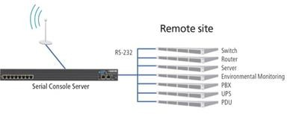

1. [0.3 points] Software-defined networking (SDN) is a relatively new technology that aims to make a network more flexible and configurable. In a conventional network, each router makes its routing tables locally based on information from and interactions with other routers. In SDN, every switch needs to have a logical connection with an SND controller, which collects global information and makes routing decisions for all routers. The logical connections can be made in either an in- band or an OOB manner, as illustrated below using red dashed lines with arrowheads. Discuss what would be the impact on the logical connections if router A fails in the in-band and the OOB cases, respectively.

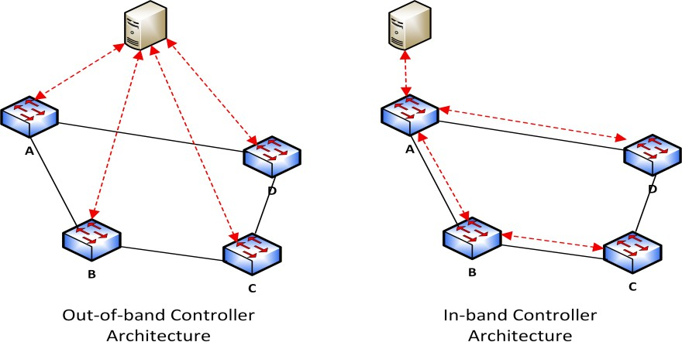

1. [0.2 points] If we must use the in-band approach to implement SDN, can you think of an idea to reduce the impact on other nodes when a single node failure as described in sub-question c happens? Here, instead of the small network in the figure, consider a practical network in which at least several nodes can directly connect to the controller.